At any stage of setup process help articles on working with Prep Business software are located here:
https://help.prepbusiness.com/
- Go to https://easyamz.ca/client-portal-login/
Select “Register/Login Calgary or Toronto Warehouse”
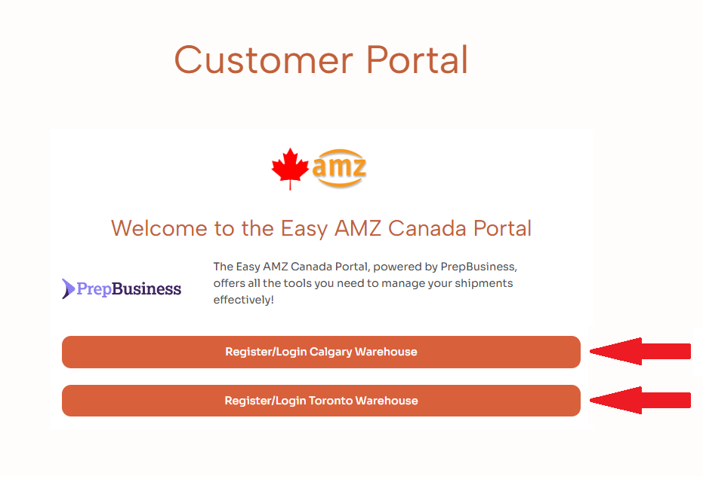

- Create new account: enter your Username (email), confirm email. Enter and confirm your password.
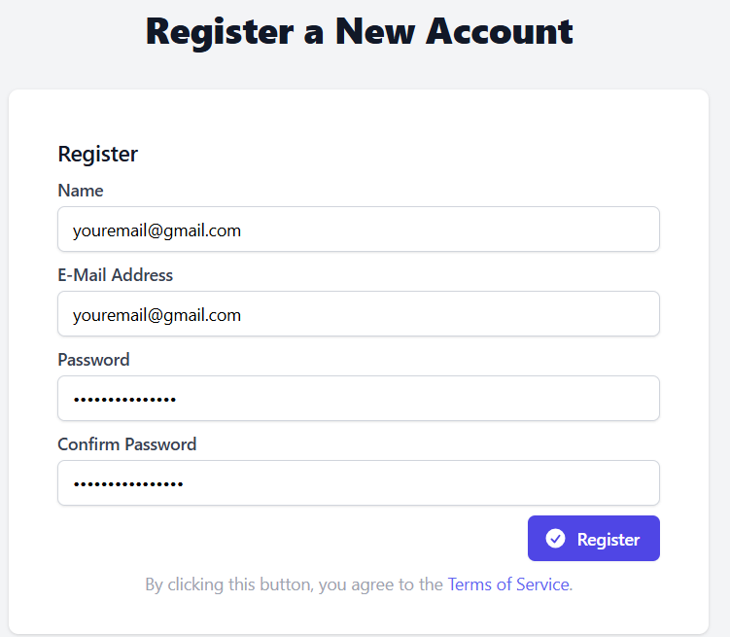

- Click “Create a New Merchant”
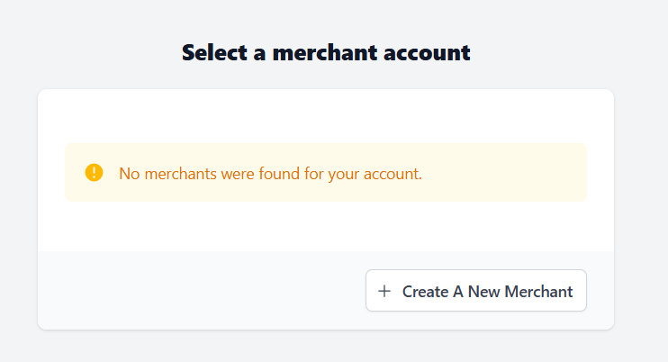

- Enter your company name and primary contact email address and click “Create Merchant Account”
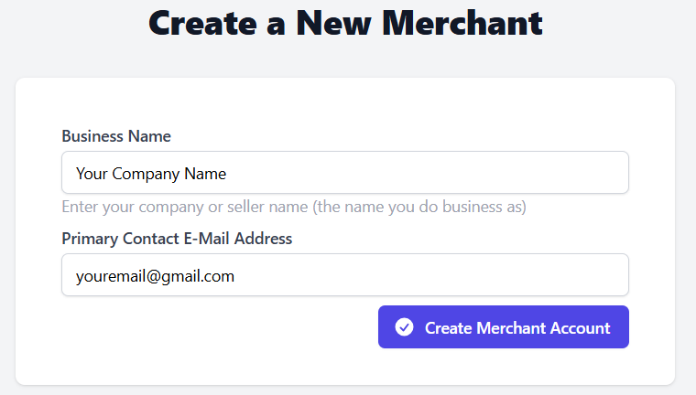
- You have successfully created your account with Easy AMZ Canada.
Please get familiar with brief tutorial
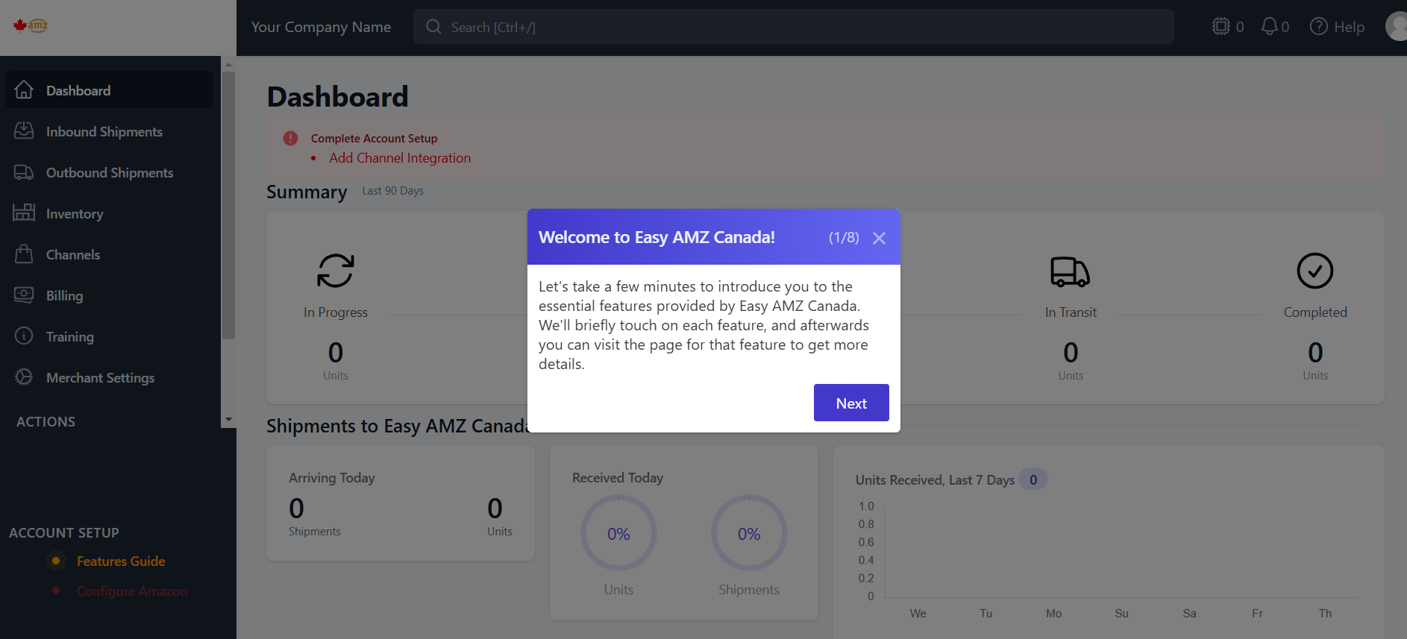

- In order to create inbound shipments to our warehouse you need to connect a selling channel.
It can be either Amazon or any other selling channel

Configure Amazon Channel
A key feature of the PrepBusiness portal is that it connects to Amazon. This enables you to sync inventory with Amazon as well as import and create Amazon shipments. To connect your account to Amazon follow these steps:
Open the Channel page.
Select the “Configure” button under Amazon.
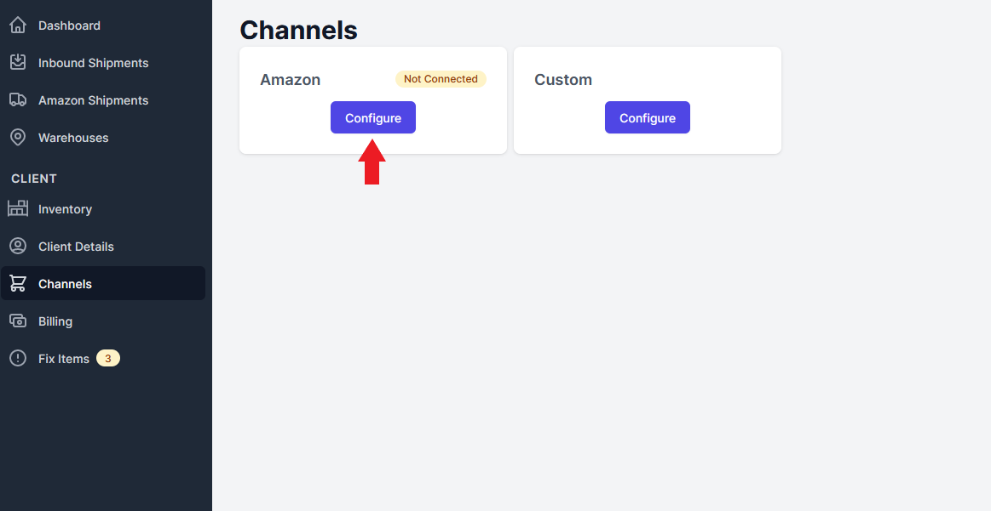
Select the country your Amazon account is in (Canada). You can also enter your store name as a reference.
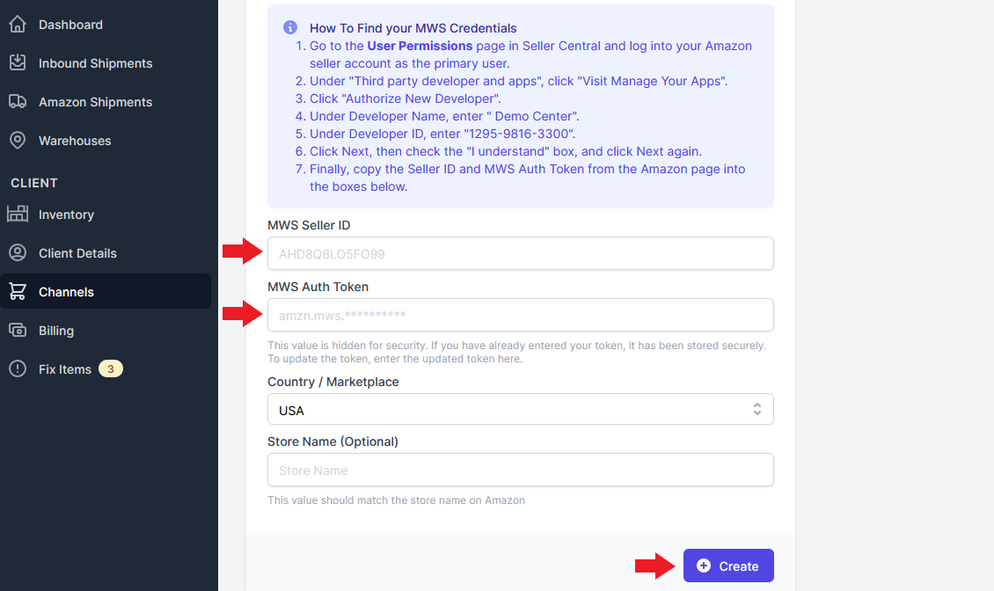
Select “Save”, and wait for the “Authorize Connection” box to appear.
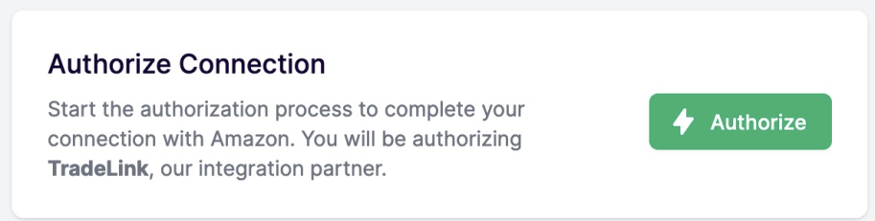
Click the “Authorize” button. Amazon will request that you log in to your account to authorize the connection. The integration name we are using is “TradeLink”. Click the Confirm button to continue.
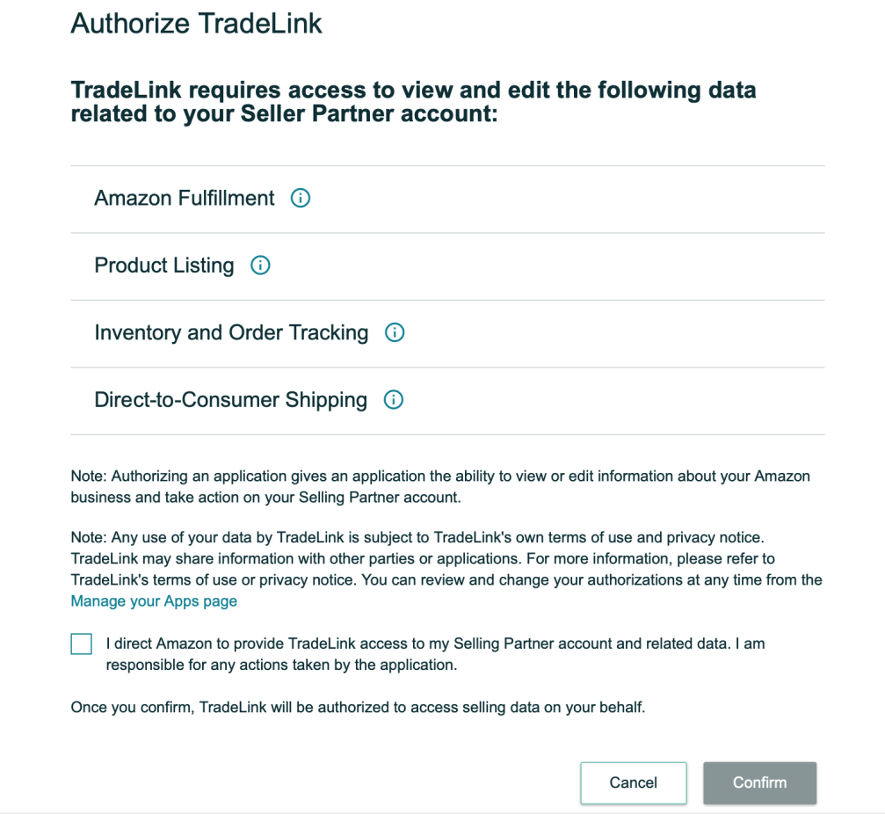
Whether you're utilizing FBA or FBM, having access to the various permissions mentioned above is crucial. These permissions are essential for effectively managing and optimizing your operations on the Amazon platform.
Amazon Fulfillment: This access allows you to efficiently manage inventory and shipping options. You can use Amazon's fulfillment services for storage, packing, and shipping.
Product Listing: With this access, the Admin can create, update, and manage product listings and identifiers from the portal, such as descriptions and images
Inventory and Order Tracking: This access view helps monitor inventory levels and track orders. It prevents stockouts and ensures timely order fulfillment.
Direct-to-Consumer Shipping: This access enables managing shipping when selling directly to consumers (FBM). Your Admin can select shipping methods and set preferences.
Congratulations, your Amazon account is now connected!

Configure Custom Channel
You can also configure a client’s account to a customized channel. To do this follow these steps:
Open the Channel page.
Select the “Configure” button under Custom.
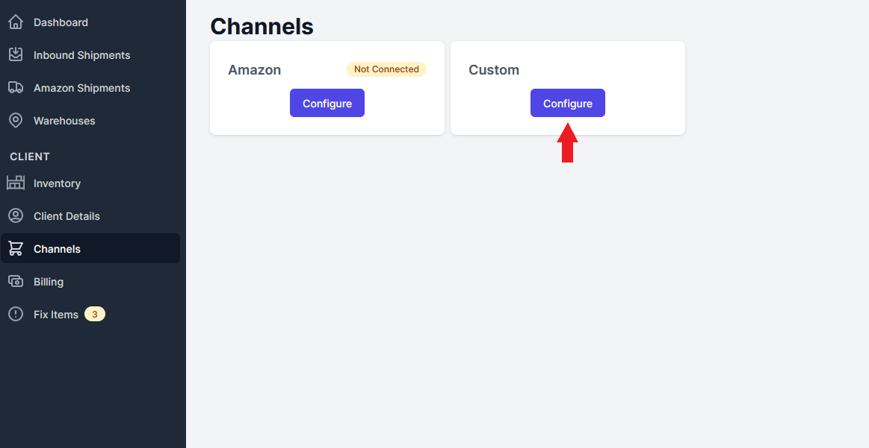
Name your channel and select “Create” to finish.
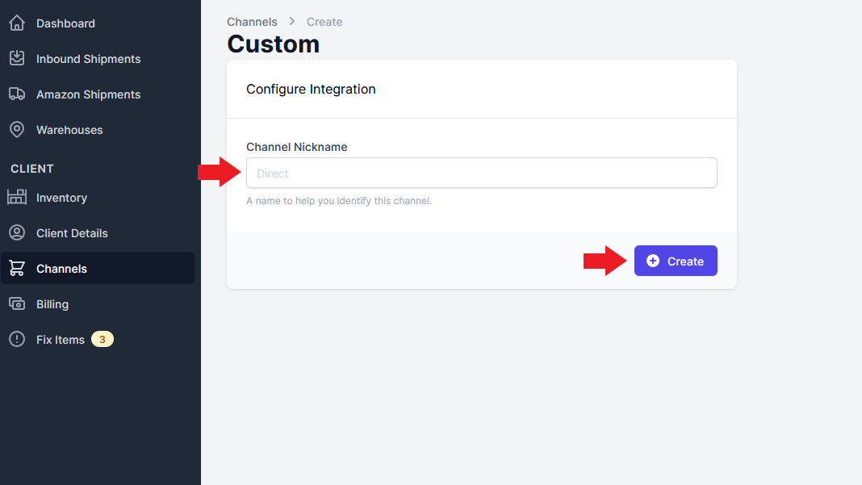

Sync Inventory to Channels
To sync the inventory you have in your warehouse with Amazon or a different, customized channel, follow these steps:
On the Channels page select “View Listings” under the channel you want.
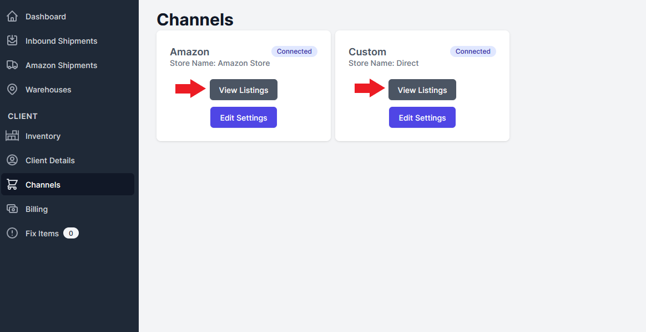
In the top right corner of the Listings page select “Sync Listings”.
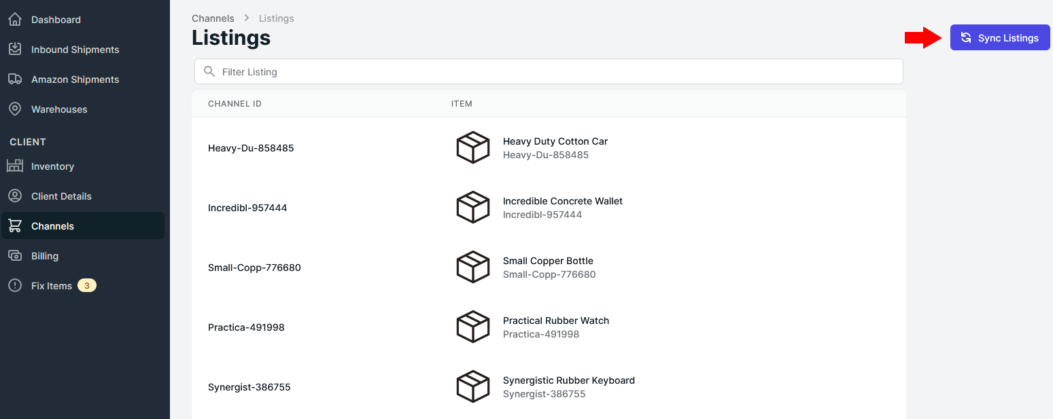

Edit Channels
Once you are configured to a channel you cannot delete it. You will only be able edit the name of the channel. To do this follow these steps:
Open the Channels page and select “Edit Settings” on the channel you want to edit.
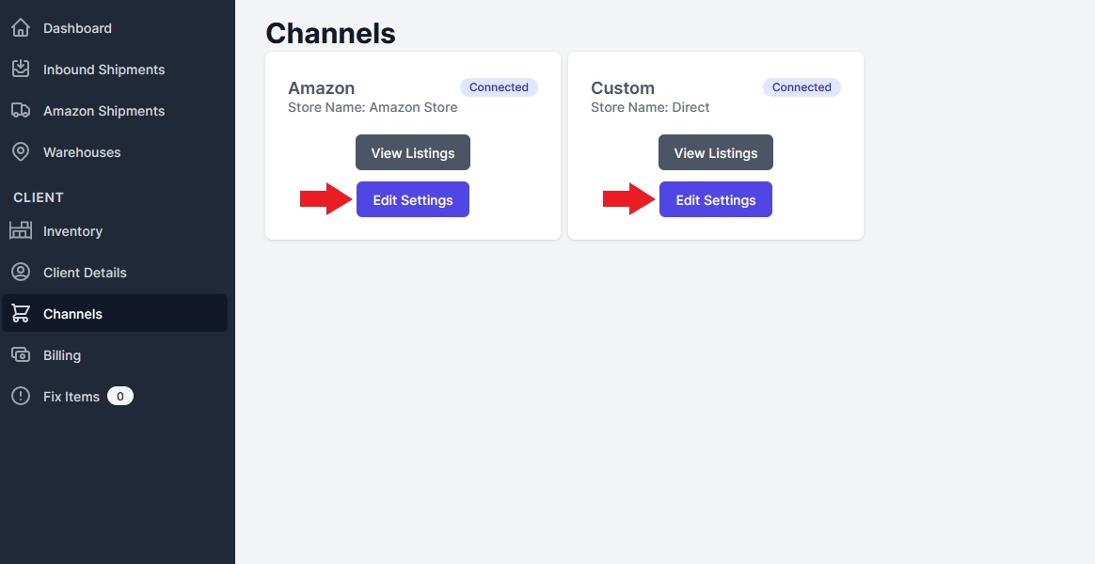
Change the name of the channel and select “Update” to finish.
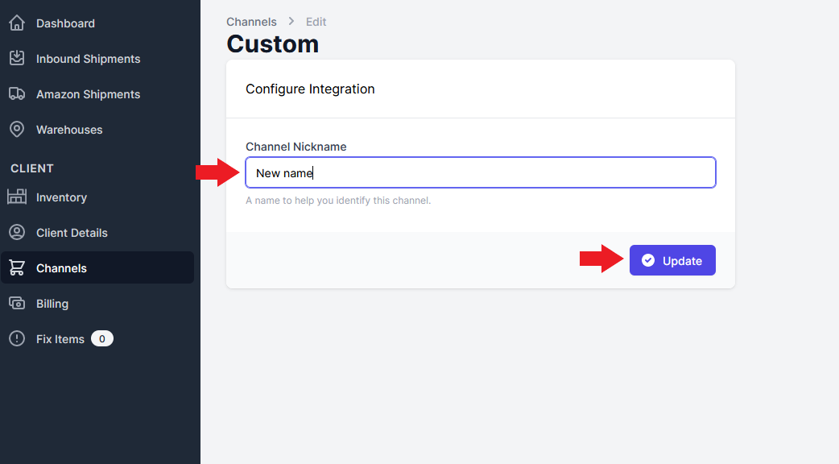

After this you can create inbound shipments

Creating an Inbound Shipment
You have the ability to create inbound shipments which ships from your supplier to our warehouse. There are two ways to create these shipments:

1. Create shipment from scratch
Basic way to create an inbound shipment is to create it from scratch. To do this open the Inbound Shipments page and select the “New Shipment” button in the top right corner.
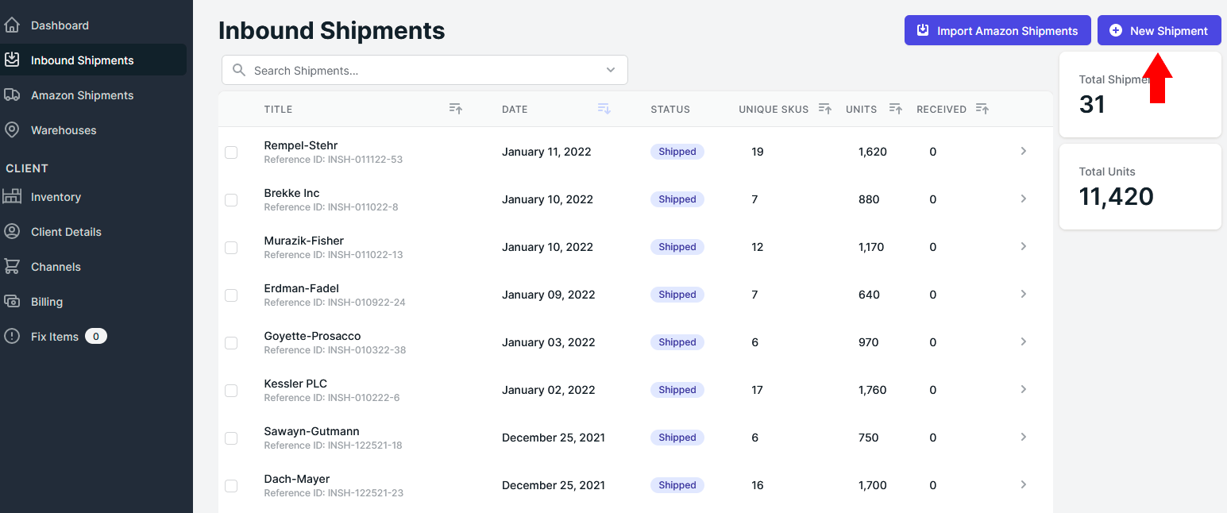
You will then have to name your shipment and specify what warehouse the shipment is being sent to.
OUR DEFAULT WAREHOUSE ADDRESSES:
#11, 41070 Cook Road, Cochrane, Alberta, Canada T4C 3A2
some postal services can reflect the same address as
#11, 41070 Cook Road, Rocky View, Alberta, Canada T4C 3A2
Both options are valid.
OR
Unit A, 63 Woodslee Ave, Paris, Ontario, Canada N3L 3N6
some postal services can reflect the same address as
Unit A, 63 Woodslee Ave, Paris, Ontario, Canada N3L 3N6

To finish, select “Create Shipment”. This will create a new and empty inbound shipment.
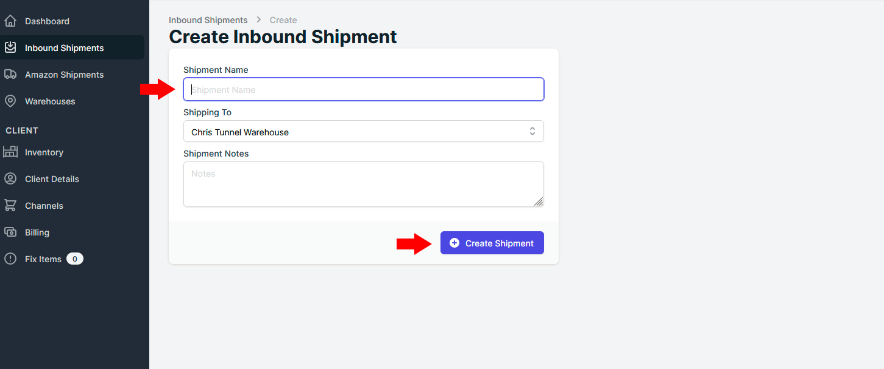

2. Import a Shipment from Amazon
You may have the option to import a shipment from Amazon if you have created an Inbound Shipment on their InventoryLab account. Since such a shipment is already registered with Amazon, importing it will create an outbound shipment on your portal in addition to an optional inbound shipment. To import a shipment from Amazon in this way, follow these steps:
On the Inbound Shipments page select the “Import Amazon Shipments” button in the top right corner.
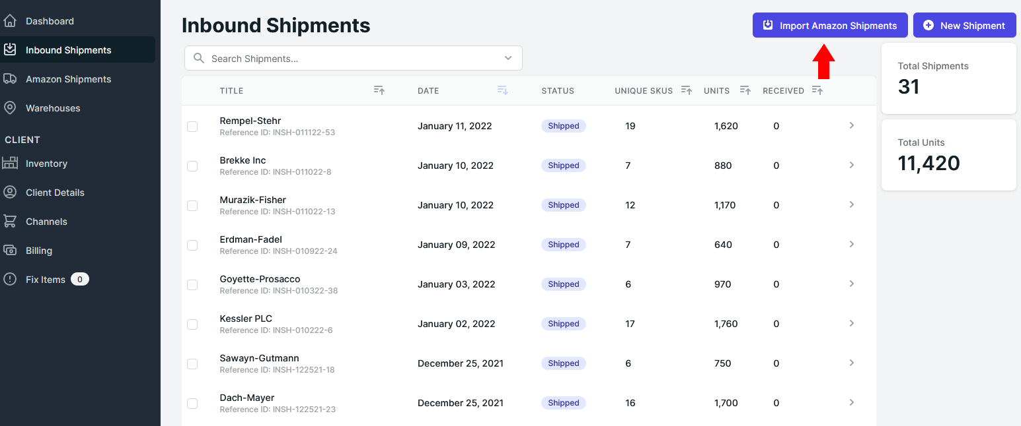
On the page there will be a list of shipments that have already been created on InventoryLab. In the Import Settings side bar, you can enter in a specific shipment’s ID in the search box to find it in the list.
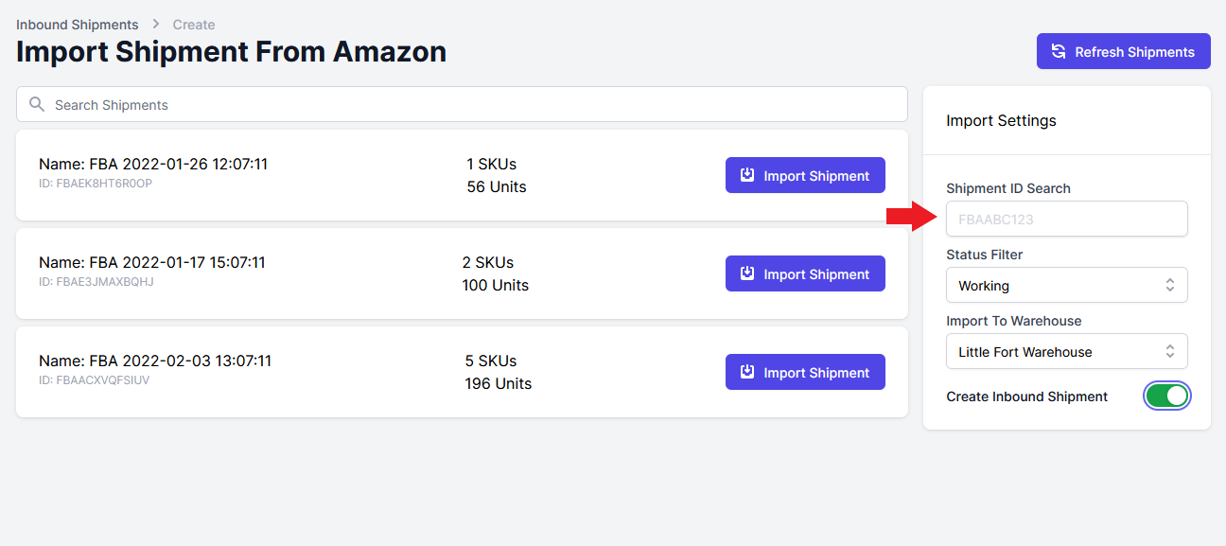
There are three other fields in Import Settings that you can control when importing a shipment:
  - The Status Filter lets you select the starting status of the inbound imported shipment. This could be anything from “Working” to “In Transit” to “Receiving”.
  - The Import To Warehouse field is where you specify which of your warehouses you are sending the shipment to.
  - The above two fields are related to inbound shipments but you don’t have to Create an Inbound Shipment for the imported shipment at all. When the toggle beside this field is green an inbound shipment will be created, otherwise only an Amazon shipment will be created.
- Once all the above settings are satisfactory, select “Import Shipment” button on the shipment you want to import.
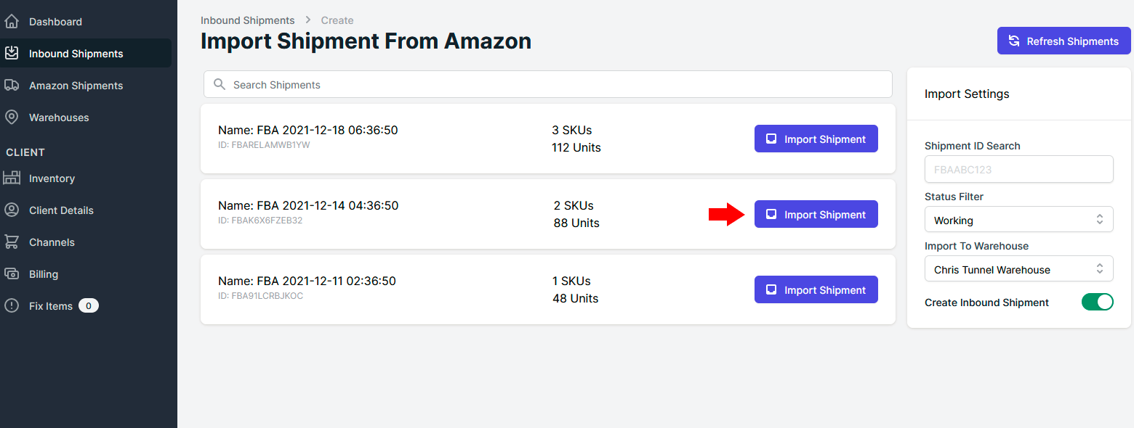

Creating Inventory
If you connected your Amazon channel, your inventory will be synced and reflected on “Inventory” tab
Otherwise, if you want to create new inventory item from other channel:
    - Select Tab “Inventory”
    - Click “Add Item”
    - Optionally you can use “Export Inventory” button for exporting multiple products
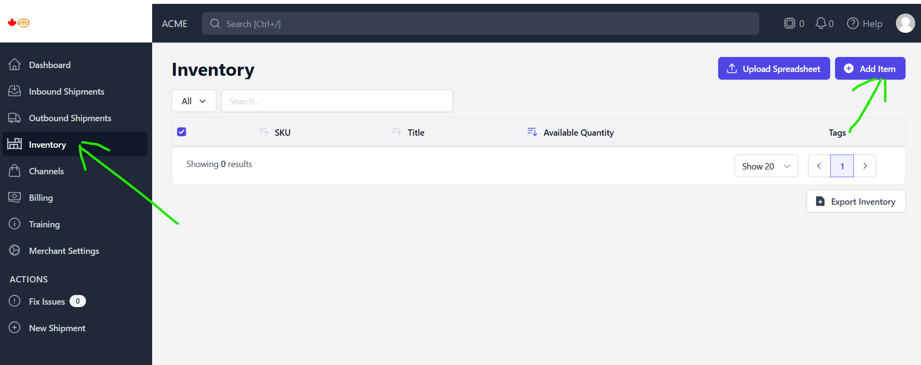
Fill in the name and title for SKU, Click “Save”. You can associate created SKU with desired channel.
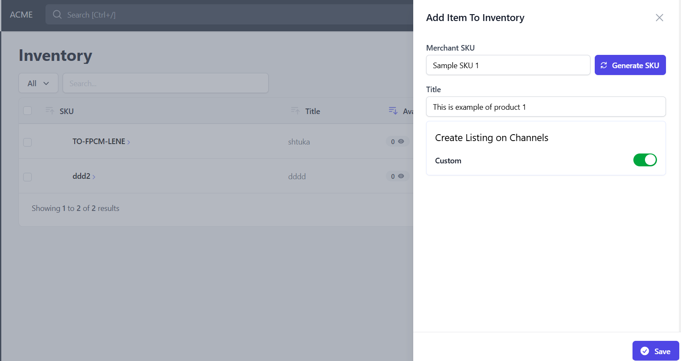
Now you can add details of your SKU that was created. Click “Inventory” tab and click on newly created SKU.
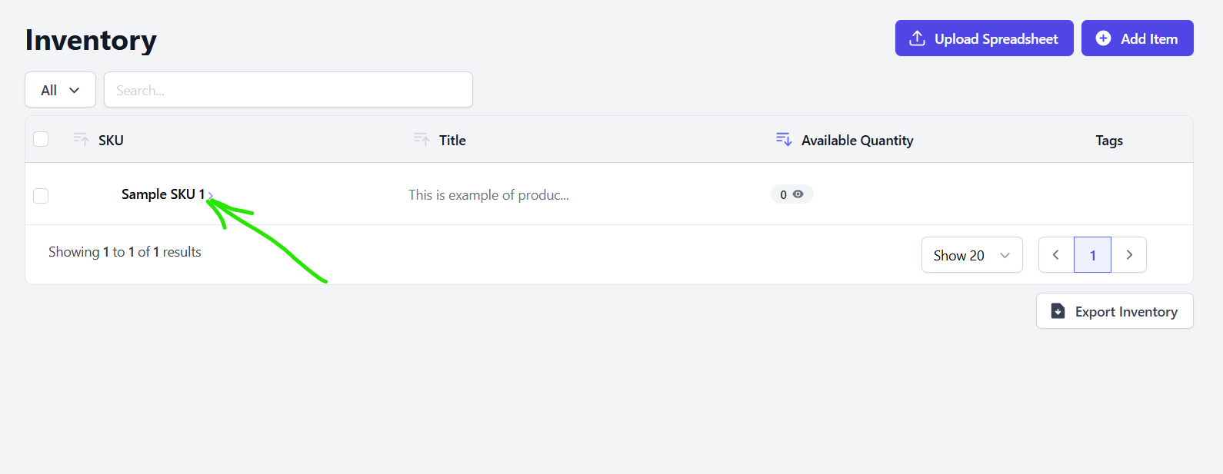
Please fill in as much details about your product as possible, including all possible identifiers, barcodes, dimensions, etc.
If you want you can add services that will be associated with the item like poly bagging, bubble wrapping, etc. Or you can leave this field blank.

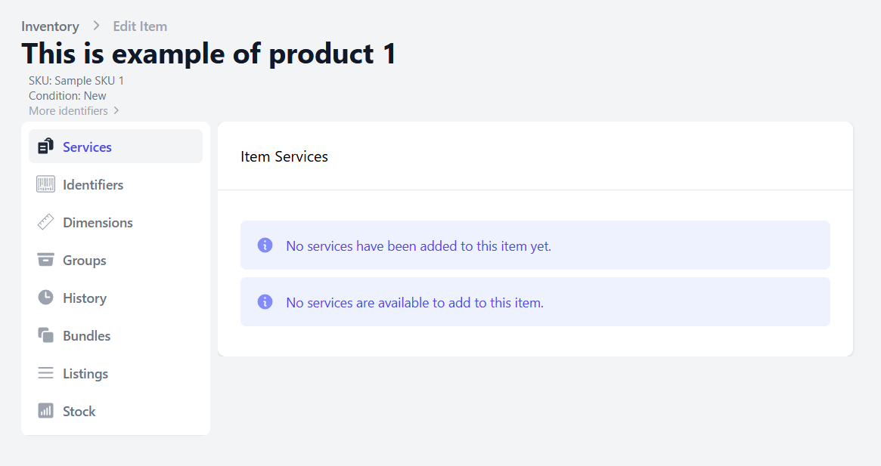
After all products has been added, you can create inbound shipments and add your products to inbound shipments.
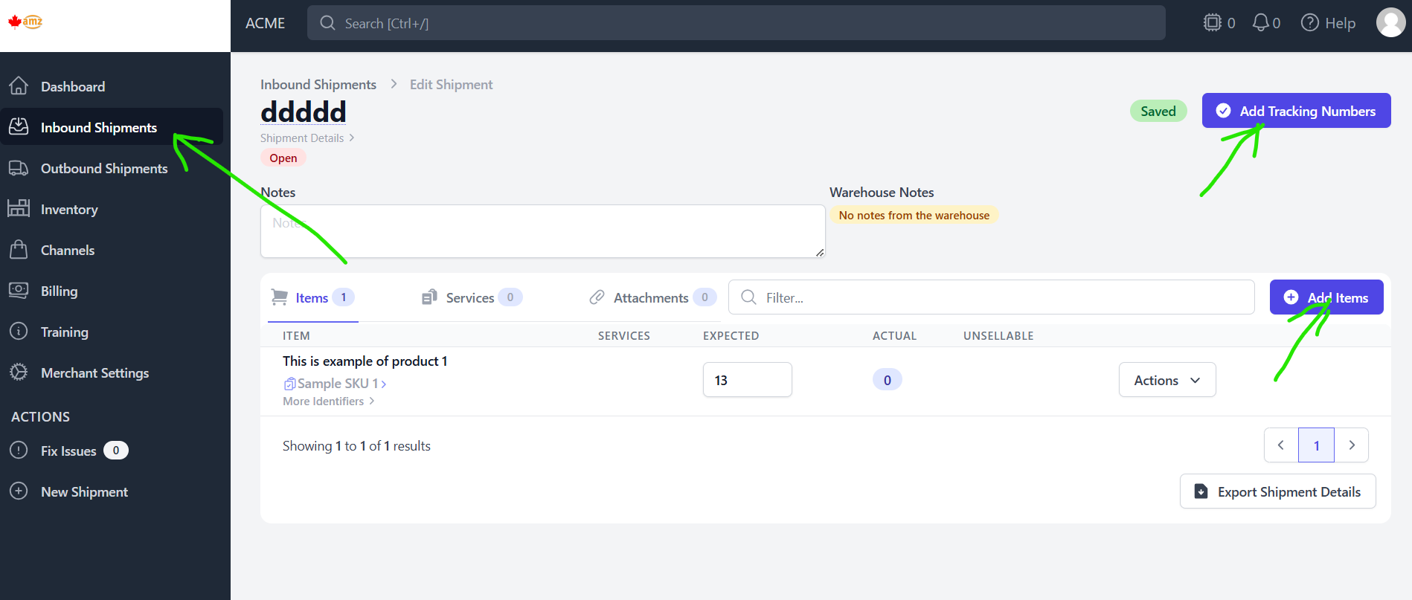

Add desired items and their quantity to inbound shipment and also add tracking numbers if known.
Please use your MERCHANT NAME in the receiver field for inbound shipments
Status of the shipment will change to “Shipped”
That completes creation of inbound shipments to our warehouse.
When we receive and verify your shipment, available quantity will be reflected in “Inventory” tab.

